**National Textile University, Faisalabad**

**Department of Computer Science**

|  |  |
| --- | --- |
| **Name:s** | M. Abdur Rehman (23-NTU-CS-1180)  M. Waqas Mahmood (23-NTU-CS-1180)  Nouman Yousaf (23-NTU-CS-1180) |
| **Class:** | BsSe (B) |
| **Semester** | 4th |
| **Lab Report:** | ATM Prototype |
| **Course Name:** | Software Requirement Engineering |
| **Submitted To:** | Mam Tehreem Jaleel |
| **Submission Date:** | 29-04-2025 |

**User Interaction with an ATM**

**Prototype:**

Below are the Prototypes of the ATM machine.

1. **Welcome Screen**

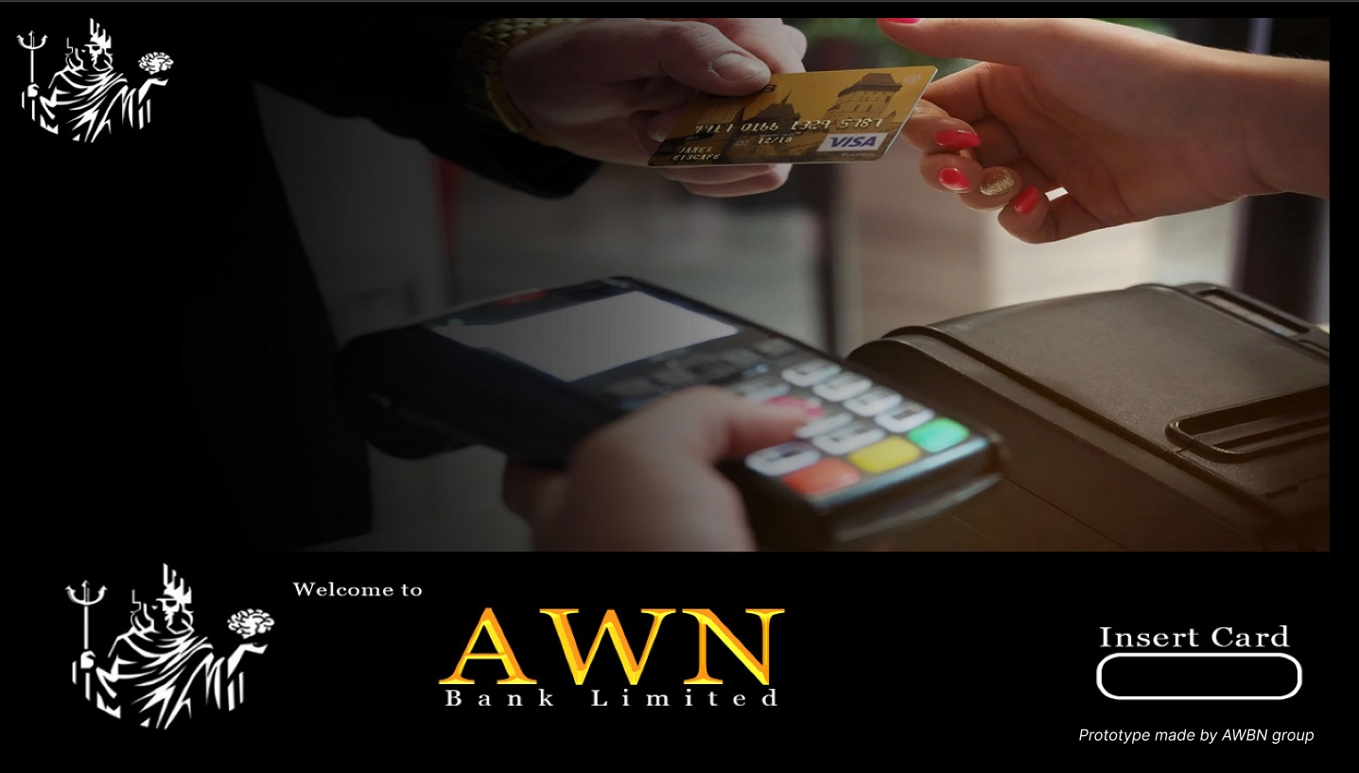

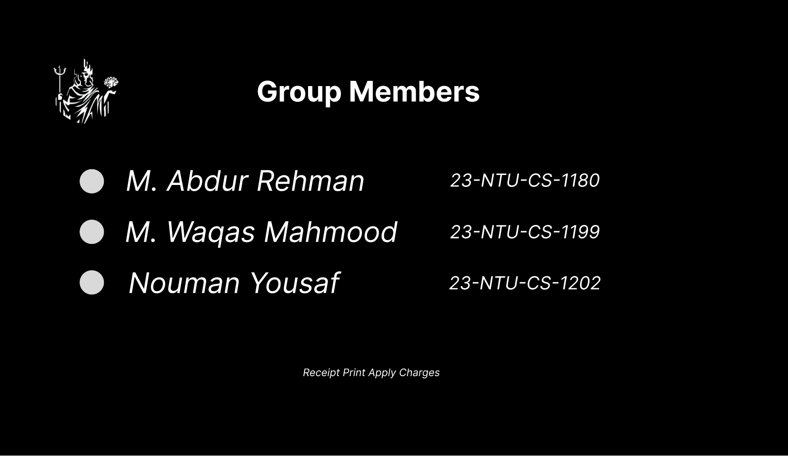

1. **Card Insertion Screen**

1. **Pin Insertion Screen**

1. **Select Transaction Screen**

1. **Enter Amount Screen**

1. **Take Cash Screen**

1. **Take Receipt Screen**

1. **Transaction complete Screen**

1. **Check Balance Screen**

1. **Deposit Amount Screen**

1. **Amount Deposit Success Screen**

1. **Transfer Funds Bank Selection Screen**

1. **Account Number’s Screen**

1. **Funds Transfer Success**

1. **Final Screen**

**Prototype Link:**

<https://www.figma.com/design/InyeVNsWWssOUenzkxixCd/ATM-Prototype?node-id=9-21&t=7xbJcdG8yPSkP4a8-1>